+ + + Press Release HEITEC AG + + +
HEITEC acquires Electronic Packaging Systems from Rittal
* Extension of HEITEC’s successful electronic division
* Completion of industrial housing portfolio
* Synergies in electronic design, production, housing construction and integration
Nuremberg, November 27th, 2012 – At the automation fair SPS/IPC/Drives in Nuremberg the German HEITEC AG, a leading supplier of industrial solutions, announced the acquisition of Rittal’s complete line of electronic packaging systems. Effective January 2013, design, production and sales of all serial products and customer specific solutions concerned will be transferred to HEITEC.
After taking over the customer specific solutions business from Rittal three years ago, with this agreement HEITEC will now continue to extend its successful electronic division by completing the product portfolio of industrial housings.
Electronic design, production, packaging and integration from a single source opens up additional synergies to provide overall solutions. Target markets include industrial automation, data and telecommunication, energy and power generation, medical technology as well as traffic and aerospace industries.
Customers will not only benefit from a wider range of services for challenging electronic applications but also from optimized internal business processes. “We are looking back on three years of close and successful cooperation with Rittal in this product line. Its complete integration in our business is a further consistent step in generating additional synergies for the benefit of our customers”, says Roland Chochoiek, Director of HEITEC’s electronic division. With this acquisition HEITEC becomes the number two in the field of electronic housing.
“In the past three years HEITEC has proven to be an ideal partner in this business. We are convinced that our customers will benefit from a sustainable and future-proof solution for standard products and customer specific applications from a single source”, adds Dr. Thomas Steffen, Managing Director Rittal GmbH & Co. KG.
Besides “classic” electronic housing systems, the transferred product line includes subracks, subrack components and accessories as well as desktop housings. Furthermore HEITEC will continue to offer special items and customer specific housings and systems.
The acquisition offers an extended range of products and services to existing and new HEITEC customers, and for existing Rittal customers continuity will be guaranteed. Part numbers and pricing remain unchanged. Sales and support in Germany will be covered by HEITEC directly, while Rittal’s sales and support channels will continue to cover the international markets until further notice. For standard products there are plans for a comprehensive international online information system.
HEITEC operates its electronic housing business from the plant located in Eckental, which was acquired by HEITEC from Rittal in 2011. Besides the production of its electronics, boards and systems, the company will continue to develop and optimize the industrial housing and system technology portfolio in the future.

About HEITEC AG
As a system provider for integrated industrial solutions, HEITEC offers solutions for the areas of automation, production systems, measurement and test engineering, electronics, software solutions, documentation and information management, among others. Our goal is to provide sustainable, cost-reducing and innovative “engineering solutions” to their customers. In cooperation with well-known universities and research institutes, they are today already creating the foundation for the developments of the future. Around 800 employees at 18 German and numerous international locations create high-quality branch solutions with direct customer proximity. HEITEC’s success is the result of long-term, trusting and cooperative partnership with their customers.
Further information at www.heitec.de
About Rittal GmbH & Co. KG
Rittal GmbH & Co. KG, which has its headquarters in Herborn, Germany, is one of the world's leading system suppliers for enclosures, power distribution, climate control, IT infrastructure and software & services. Customers from all sectors of industry, from mechanical and plant engineering, as well as from the IT and telecoms market are making use of system solutions from Rittal.
Its broad product range also includes complete solutions for modular and energy-efficient data centres: from innovative security concepts for data systems through to physical data and system security for IT infrastructures. The leading software provider Eplan and the software and consultancy company Mind8 supplement the Rittal product portfolio with interdisciplinary engineering solutions.
Founded in 1961, Rittal is now active worldwide with 11 production sites, 64 subsidiaries and 40 agencies. With 10,000 employees worldwide, Rittal is the largest company of the proprietor-run Friedhelm Loh Group of Haiger, Germany. The entire group employs 11,500 people and generated revenues of € 2.2 billion in 2011. Further information at www.rittal.com and www.friedhelm-loh-group.com.

Contact Information
HEITEC AG  Roland Chochoiek  Dr.-Otto-Leich-Str. 16  90542 Eckental  Tel: 09126-2934-0  elektronik@heitec.de  www.heitec.de | KEK Concept GmbH  Evelyn Stepken  Hofer Str. 1  81737 München  Tel: +49(0)89 6734 6144  estepken@kek-concept.de  www.kek-concept.de

Pictures

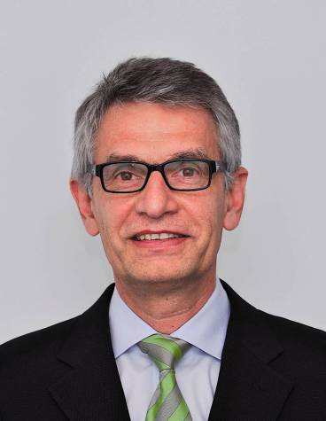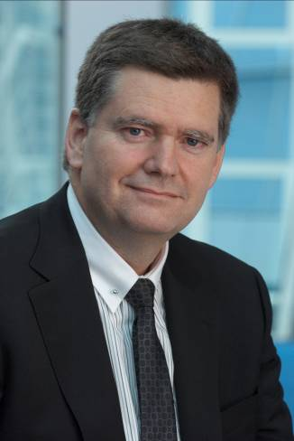

Johannes Feldmayer, Roland Chochoiek,

Generalbevollmächtigter HEITEC Geschäftsgebietsleiter Elektronik HEITEC

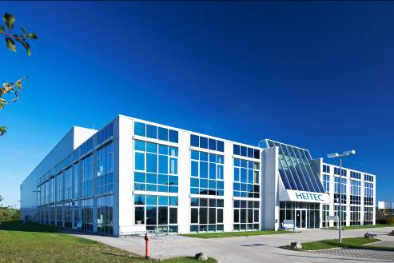
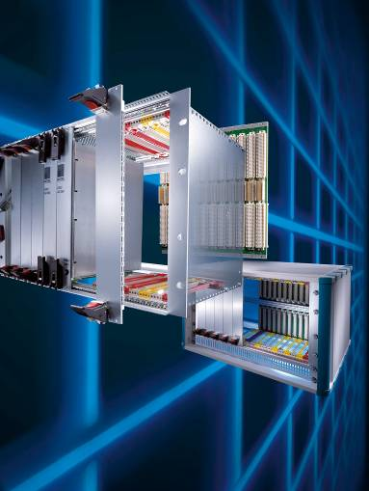

HEITEC-Building in Eckental-Eschenau

Elektronik-Aufbausystem

